INDEX (Module 2)

Topics Page No.

2.1. Binary Adder (Half adder) 2

2.2. Full Adder 3

2.3. n- Bit Ripple Carry Adder 5

2.4. Carry Look Ahead Adder 6

2.5. Half Subtractor 8

2.6. Full Subtractor 9

2.7. Carry Save Adder 11

2.8. BCD Adder 13

2.9 Magnitude Comparator 16

2.10 Multiplexer 17

2.11 Boolean Function Implementation using Multiplexer 19
2.12 Demultiplexers 21
2.13 Decoder 23

2.14 Implementing Logic Functions Using Decoders 25

2.15 Encoder 26

Combinational Circuits
Digital logic may be divided into two classes: combinational logic, in which the logical outputs are determined by the logical function being performed and the logical input states at that particular moment; and sequential logic, in which the outputs also depend on the prior states of those outputs. Both classes of logic are used extensively in all digital computers.
Since both types of logic circuits begin with logic gates to combine logical input signals in various ways to produce the desired outputs.

2.1 Binary Adder

Adders are the basic building blocks of all the arithmetic circuits, adders add two binary numbers and give out sum and carry as output. Basically we have two types of adders. Half Adder and Full adder.

Half Adder

Adding two single-bit binary values, A,B produces a Sum bit and a carry out Carry bit. This operation is called half addition and the circuit to realize it is called a half adder.

Truth Table:
A | B | Sum | Carry
0 | 0 | 0 | 0
0 | 1 | 1 | 0
1 | 0 | 1 | 0
1 | 1 | 0 | 1

Symbol

A SUM
HA

B Carry

Sum = A'B + AB' =A ⊕ B,

Carry = AB

There are four possibilities, these are as follows.
- When A = 0 and B = 0.
Sum = A ⊕ B = 0 ⊕ 0 = 0
Carry = A.B = 0.0 = 0.
- When A = 0 and B = 1.
Sum = A ⊕ B = 0 ⊕ 1 = 1
Carry = A.B = 0.1 = 0.
- When A = 1 and B = 0.
Sum = A ⊕ B = 1 ⊕ 0 = 1
Carry = A.B = 1.0 = 0.
- When A = 1 and B = 1.
Sum = A ⊕ B = 1 ⊕ 1 = 1
Carry = A.B = 1.1 = 1.
These results are summarized in the truth table as shown above. The addition of two numbers by using the binary rule and above circuit is the same therefore the above circuit is called as half adder.

Logic Circuit

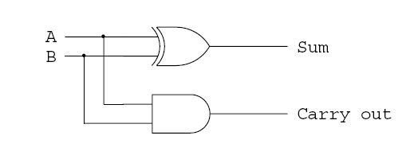

2.2 Full Adder

Full adder takes three bit input. Adding two single-bit binary values, X, Y with a carry input bit C-in produces a sum bit S and a carry out C-out bit.

Truth Table
A | B | C | Sum | Carry
0 | 0 | 0 | 0 | 0
0 | 0 | 1 | 1 | 0
0 | 1 | 0 | 1 | 0
0 | 1 | 1 | 0 | 1
1 | 0 | 0 | 1 | 0
1 | 0 | 1 | 0 | 1
1 | 1 | 0 | 0 | 1
1 | 1 | 1 | 1 | 1

Sum =A BC

Carry = (A B)C+A.B

Symbol

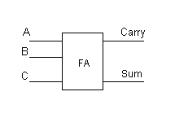

Logic Circuit

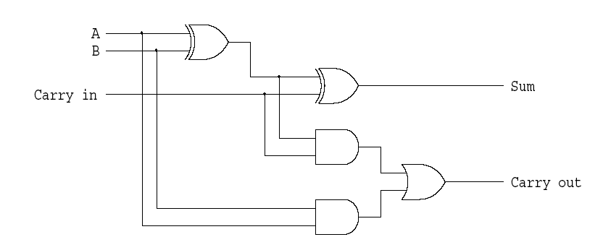

Full adder using 2 half adders

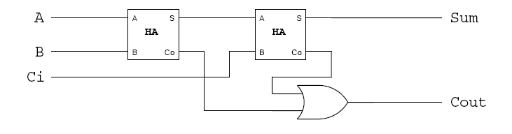

2.3 n-bit Ripple Carry Adder/Parallel binary adder

An n-bit adder used to add two n-bit binary numbers can build by connecting in series n full adders. Each full adder represents a bit position j (from 0 to n-1).

Each carry out C-out from a full adder at position j is connected to the carry in C-in of the full adder at the higher position j+1.

In the expression of the sum Cj must be generated by the full adder at the lower position j-1. The propagation delay in each full adder to produce the carry is equal to two gate delays = 2 D Since the generation of the sum requires the propagation of the carry from the lowest position to the highest position , the total propagation delay of the adder is approximately:
Total Propagation delay = 2 nD

4-bit Carry Ripple Adder

Adds two 4-bit numbers: A = A_{0,} A_{1,} A_{2,} A₃ , B = B_{0,} B_{1,} B_{2,} B₃. Producing the sum S = S3 S2 S1 S0 and C-out = C4 from the most significant.
A₃ A₂ A₁ A₀
B₃ B₂ B₁ B₀
₋₋₋₋₋₋₋₋₋₋₋₋₋₋₋₋₋₋₋₋₋₋₋₋
S₃ S₂ S₁ S₀
The first column requires only a half adder. For any column above the first there may be a carry from preceding column. Therefore we must use a full adder for each column above the first.

Total Propagation delay = 2 nD = 8D or 8 gate delays

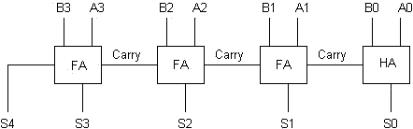

Complete circuit of 4 bit parallel binary adder

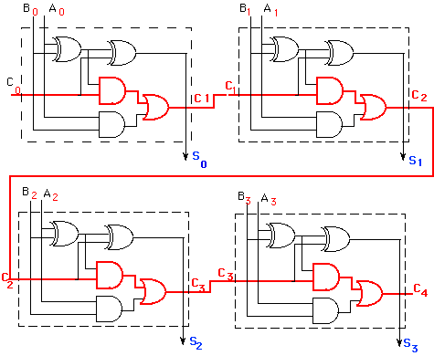

2.4 Carry Look-Ahead Adder
The delay generated by an N-bit adder is proportional to the length N of the two numbers Aand B that are added because the carry signals have to propagate from one full-adder to the next. For large values of N, the delay becomes unacceptably large so that a special solution needs to be adopted to accelerate the calculation of the carry bits. This solution involves a look-ahead carry generator which is a block that simultaneously calculates all the carry bits involved. Once these bits are available to the rest of the circuit, each individual three-bit addition (A_{i}+B_{i}+C_{i}) is implemented by a simple 3-input XOR gate. The design of the look-ahead carry generator involves two Boolean functions named Generate and the Propagate.

For each pair of input bits these functions are defined as:
G_{i} = A_{i}.B_{i}
Pi = (A_{i} + B_{i})
The carry bit carry-out_{i} generated when adding two bits Xi and Yi is '1' if the corresponding function Gi is '1' or if the carry_outi-1='1' and the function Pi = '1' simultaneously. In the first case, the carry bit is activated by the local conditions (the values of Xi and Yi). In the second, the carry bit is received from the less significant elementary addition and is propagated further to the more significant elementary addition. Therefore, the carry-out bit corresponding to a pair of bits Xi and Yi is calculated according to the equation:
C_{OUT} = C_{i+1} = A_{i}.B_{i} + (A_{i} + B_{i}).C_{i.}
For a four-bit adder the carry-outs are calculated as follows
C₁ = G₀ + P₀.C₀
C₂ = G₁ + P₁.C₁ = G₁ + P1.G₀ + P₁.P₀.C₀
C₃ = G₂ + P₂.G₁ + P₂.P₁.G₀ + P₂.P₁.P₀.C₀
C₄ = G₃ + P₃.G₂ + P₃.P₂.G₁ + P₃P₂.P₁.G₀ + P₃P₂.P₁.P₀.C₀
The set of equations above are implemented by the circuit below and a complete adder with a look-ahead carry generator is next. Sum output of this adder is as follows
S₀ = A₀.B₀.Cout₀
S₁ = A₁.B₁.Cout₁
S₀ = A₂.B₂.Cout₂
S₀ = A₃.B₃.Cout₃
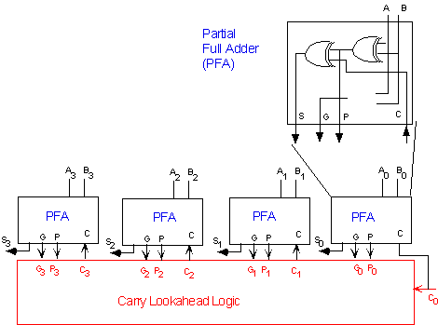

2.5 Binary Subtractor
Subtractor circuits take two binary numbers as input and subtract one binary number input with other binary number input. Similar to adders it gives out two output, difference and borrow (Carry in the case of Adder). There are two types of subtractors. Half Subtractor and Full Subtractor.
Half Subtractor
The half-subtractor is a combinational circuit which is used to perform subtraction of two bits. It has two inputs, X (minuend) and Y (subtrahend) and two outputs D (difference) and B (borrow). The logic symbol, Truth table is shown below
Symbol
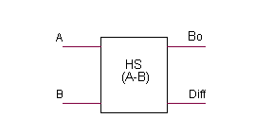
A | B | R | B
0 | 0 | 0 | 0
0 | 1 | 1 | 1
1 | 0 | 1 | 0
1 | 1 | 0 | 0

From above truth table we can get the Boolean expression for "difference" and "borrow".
Difference R= A B
Borrow B=A’B
From the equation we can draw the half-subtractor as shown in figure below.
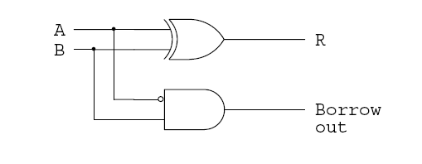
2.6 Full Subtractor
A full subtractor is a combinational circuit that performs subtraction involving three bits, namely minuend, subtrahend, and borrow in. The logic symbol, Truth table is shown below.
Symbol
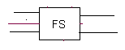
Truth Table
A | B | Bin | R | Bout
0 | 0 | 0 | 0 | 0
0 | 0 | 1 | 1 | 1
0 | 1 | 0 | 1 | 1
0 | 1 | 1 | 0 | 1
1 | 0 | 0 | 1 | 0
1 | 0 | 1 | 0 | 0
1 | 1 | 0 | 0 | 0
1 | 1 | 1 | 1 | 1

From above table we can draw the Kmap for "difference" and "borrow". The Boolean expression for the difference and Borrow can be written.
D = A'B'Bin + A'BBin' + AB'Bin' + AB Bin
= (ABY)'Bin + (A B)Bin'
= A B Bin
Bout = A'.BY + A'.Bin + B.Bin

From the above expression, we can draw the circuit below. If you look carefully, you will see that a full-subtractor circuit is more or less same as as full-adder with slight modification.
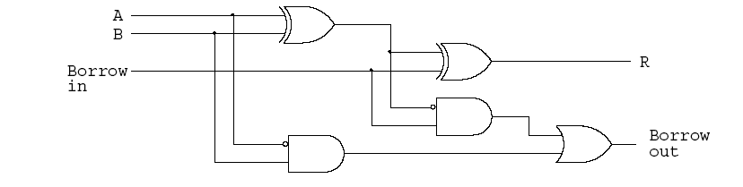

Full subtractror using half syubtractors.
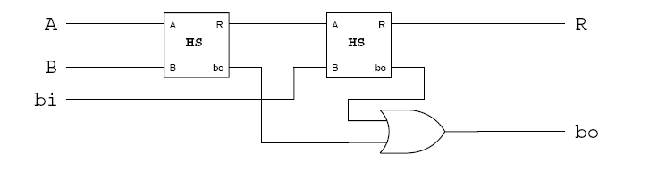
4 Bit binary subtractor
Just like the 4 bit adder we can draw the logic diagram of 4-bit subtractor.
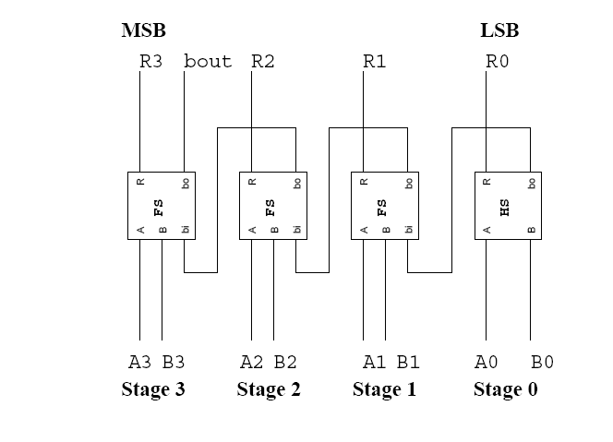

2.7 Carry save Adder
There are many cases where it is desired to add more than two numbers together. The straightforward way of adding together m numbers (all n bits wide) is to add the first two, then add that sum to the next, and so on. This requires a total of m − 1 additions.

Using carry save addition, the delay can be reduced further still. The idea is to take 3 numbers that we want to add together, x + y + z, and convert it into 2 numbers c + s such that x + y + z = c + s.

In carry save addition, we refrain from directly passing on the carry information until the very last step. We will first illustrate the general concept with a base 10 example.

To add three numbers by hand, we typically align the three operands, and then proceed column by column in the same fashion that we perform addition with two numbers. The three digits in a row are added, and any overflow goes into the next column. Observe that when there is some non-zero carry, we are really adding four digits (the digits of x,y and z, plus the carry).

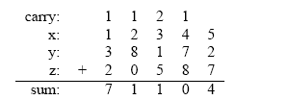
The carry save approach breaks this process down into two steps. The first is to compute the sum ignoring any carries:
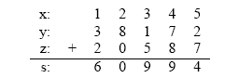

Each si is equal to the sum of xi + yi + zi modulo 10. Now, separately, we can compute the carry on a column by column basis:

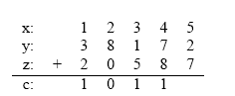
In this case, each ci is the sum of the bits from the previous column divided by 10 (ignoring any remainder). Another way to look at it is that any carry over from one column gets put into the next column. Now, we can add together c and s, and we’ll verify that it indeed is equal to
x + y + z.

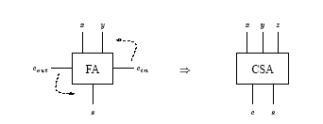

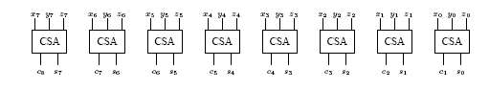

One CSA block is used for each bit. This circuit adds three n = 8 bit numbers together into two new numbers.
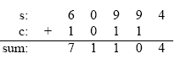
The important point is that c and s can be computed independently, and furthermore, each ci (and si) can be computed independently from all of the other c’s (and s’s).

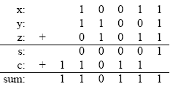
A carry save adder simply is a full adder with the cin input renamed to z, the z output (the original “answer” output) renamed to s, and the cout output renamed to c.

2.8 BCD Adder

In the BCD representation system each digit is encoded into its binary equivalent with four (4) bits.
Decimal | BCD
0 | 0000
1 | 0001
2 | 0010
3 | 0011
4 | 0100
5 | 0101
6 | 0110
7 | 0111
8 | 1000
9 | 1001

For example, let's consider the addition of the two BCD digits 5 and 3:

Now consider the sum of 5 and 8:

The sum is 1101₂ = 13, but this result should be correctly represented as 0001 0011 in BCD notation. Fortunately, there is a simple way to find the correct result. We add 6 (0110₂) to the digit sum if it exceeds 9. Let's examine the following cases:
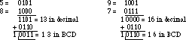
In both cases, by adding six we obtain the correct answer in BCD.

BCD Adder Design
When we add two BCD numbers we can get sum ranges from 0-19. Consider a 4 bit binary adder the adder output named K (carry output) P₃P₂P₁P₀ . if this out put is lass than or equal to 9 then that is a valid BCD number. If it is greater than 9 there should be some corrective action taken. This circuit is given below. And the out put of the corrective network named as CoutZ₃Z₂Z₁Z₀

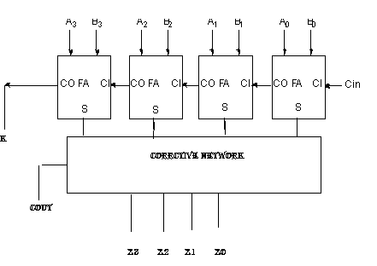

If KP₃P₂P₁P₀=CoutZ₃Z₂Z₁Z₀ there is no corrective procedure is needed. On the other hand when two decimal is added and the adder produce the output KP₃P₂P₁P₀= 01010, 01011,……10011which corresponds to decimal sums of 10 through 19, corrective action must be taken to get appropriate values for CoutZ₃Z₂Z₁Z₀.

Design of correction network

Decimal | Binary Sum |  |  |  |  | Required BCD sum
Decimal | K | P₃ | P₂ | P₁ | P₀ | C_{out} | Z₃ | Z₂ | Z₁ | Z₀
0 | 0 | 0 | 0 | 0 | 0 | 0 | 0 | 0 | 0 | 0
1 | 0 | 0 | 0 | 0 | 1 | 0 | 0 | 0 | 0 | 1
2 | 0 | 0 | 0 | 1 | 0 | 0 | 0 | 0 | 1 | 0
3 | 0 | 0 | 0 | 1 | 1 | 0 | 0 | 0 | 1 | 1
4 | 0 | 0 | 1 | 0 | 0 | 0 | 0 | 1 | 0 | 0
5 | 0 | 0 | 1 | 0 | 1 | 0 | 0 | 1 | 0 | 1
6 | 0 | 0 | 1 | 1 | 0 | 0 | 0 | 1 | 1 | 0
7 | 0 | 0 | 1 | 1 | 1 | 0 | 0 | 1 | 1 | 1
8 | 0 | 1 | 0 | 0 | 0 | 0 | 1 | 0 | 0 | 0
9 | 0 | 1 | 0 | 0 | 1 | 0 | 1 | 0 | 0 | 1
10 | 0 | 1 | 0 | 1 | 0 | 1 | 0 | 0 | 0 | 0
11 | 0 | 1 | 0 | 1 | 1 | 1 | 0 | 0 | 0 | 1
12 | 0 | 1 | 1 | 0 | 0 | 1 | 0 | 0 | 1 | 0
13 | 0 | 1 | 1 | 0 | 1 | 1 | 0 | 0 | 1 | 1
14 | 0 | 1 | 1 | 1 | 0 | 1 | 0 | 1 | 0 | 0
15 | 0 | 1 | 1 | 1 | 1 | 1 | 0 | 1 | 0 | 1
16 | 1 | 0 | 0 | 0 | 0 | 1 | 0 | 1 | 1 | 0
17 | 1 | 0 | 0 | 0 | 1 | 1 | 0 | 1 | 1 | 1
18 | 1 | 0 | 0 | 1 | 0 | 1 | 1 | 0 | 0 | 0
19 | 1 | 0 | 0 | 1 | 1 | 1 | 1 | 0 | 0 | 1

Consider the situation KP₃P₂P₁P₀= 10000,10001,10010,10011. In each case K=1, and

C_{out} is Also 1. In these cases there should be some corrective procedure is needed. In order to obtain a correct BCD number, add 6 to the sum obtained by the 4-bit adder.

Consider another situation sum is ranges from 10 to 15. In these cases also the sum is not a valid BCD number. So add 6. These situations are P₃ P₂ ‘ P₁ P₀’+ P₃ P₂ ‘P₁ P₀ + P₃ P₂ P₁’ P₀ ‘+
P₃ P₂ P₁’ P₀+ P₃ P₂ P₁ P₀’ + P₃ P₂ P₁ P₀ Simplify this expression u will get P₃ P₂+ P₃ P₁
So add 6= K+ P₃ P₂+ P₃ P₁
The corrective network is given below.
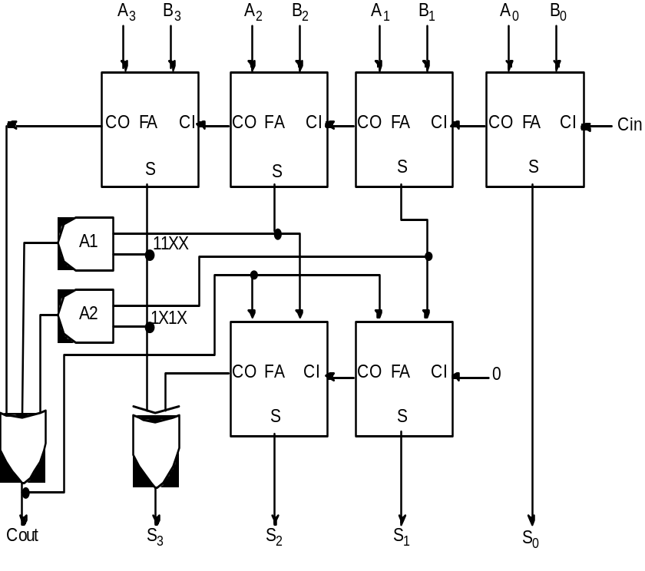

The AND gates labeled A1 and A2 detect the conditions under which the first-level sum matches the patterns 11XX₂ and 1X1X₂. These are exactly the cases in which this sum exceeds 9. When carry-out is asserted, the XOR gate and the adders in the second row effectively add 0110₂ to the first row's sum.
There is one further case to consider. The correction factor should also be applied whenever the first-row sum exceeds 15.
Thus the sum exceeds 9 if either the first-row carry-out is asserted, or the sum matches the pattern 11XX₂, or the sum matches the pattern 1X1X₂. These are precisely the inputs to the OR gate that computes the BCD carry-out.

2.9 Magnitude Comparators
The basic function of Comparator is to compare the magnitude of two quantities in order to determine the relationship between the quantities. The XOR gate is the basic comparator element in order to determine two quantities are equal, because the output of the XOR gate is equal to 0 when two quantities are equal. If A =A_{n}…….A₁ A₀ and B = B_{n}……B₁ B₀ are the two quantities.

A INPUT | B INPUT | OUTPUT
0 | 0 | 0
0 | 1 | 1
1 | 0 | 1
1 | 1 | 0

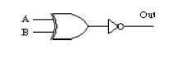
Output 1, indicate the given numbers are equal.

Consider the 4 bit comparator circuit.
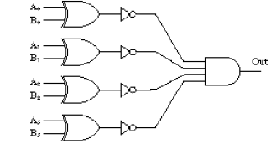
The comparison process of two positive numbers A and B is performed in a bit-by-bit manner starting with the most significant bit.
- If the most significant bits are An='1' and Bn='0' then number A is larger then B.
- If An='0' and Bn='1' then number A is smaller then B.
- If An=Bn then numbers no decision can be taken about A and B based only on these two bits.
If the most significant bits are equal then the result of the comparison is determined by the less significant bits An-1 and Bn-1. If these bits are equal as well, the process continues with the next pair of bits. If all bits are equal then the two numbers are equal. Logic circuit of 4 bit comparator is given below.
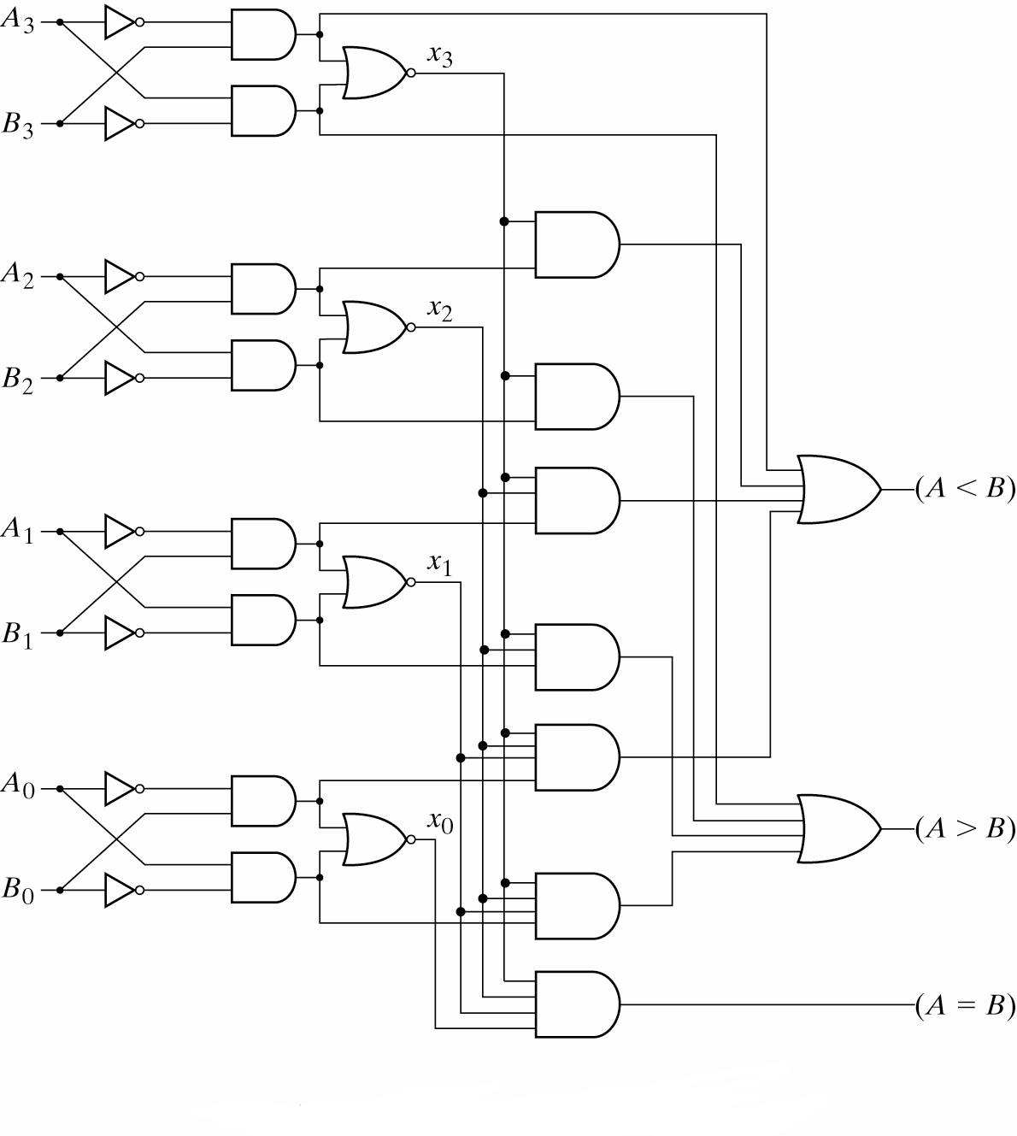
2.10 Multiplexer
The circuit that selects one of the several source lines at the transmitting end is referred to as multiplexer. Multiplex means many into one. A multiplexer is a circuit with many inputs but only one output. By applying control signals, we can steer any input to the output.
The multiplexer circuit is typically used to combine two or more digital signals onto a single line, by placing them there at different times. The figure below illustrates the general idea. The circuit has n input signals, m control signals/select lines, and 1 output signal.
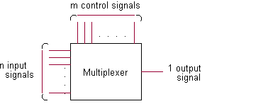

A typical example is the telephone network combines multiple audio signals onto a single pair of wires using exactly this technique, and is readily able to separate many telephone conversations so that everyone's voice goes only to the intended recipient. With the growth of the Internet and the World Wide Web, most people have heard about T1 telephone lines. A T1 line can transmit up to 24 individual telephone conversations by multiplexing them in this manner. A very common application for this type of circuit is found in computers, where dynamic memory uses the same address lines for both row and column addressing. A set of multiplexers is used to first select the row address to the memory, then switch to the column address. This scheme allows large amounts of memory to be incorporated into the computer while limiting the number of copper traces required to connect that memory to the rest of the computer circuitry. In such an application, this circuit is commonly called a data selector. Multiplexers are not limited to two data inputs. If we use two addressing inputs, we can multiplex up to four data signals. With three addressing inputs, we can multiplex eight signals.
2-1 multiplexer
There are 2 input lines and 1 selection line whose bit determines which input line is selected. If selection S is zero then I₀ has the path to output and if S is one I₁ has the path to output.

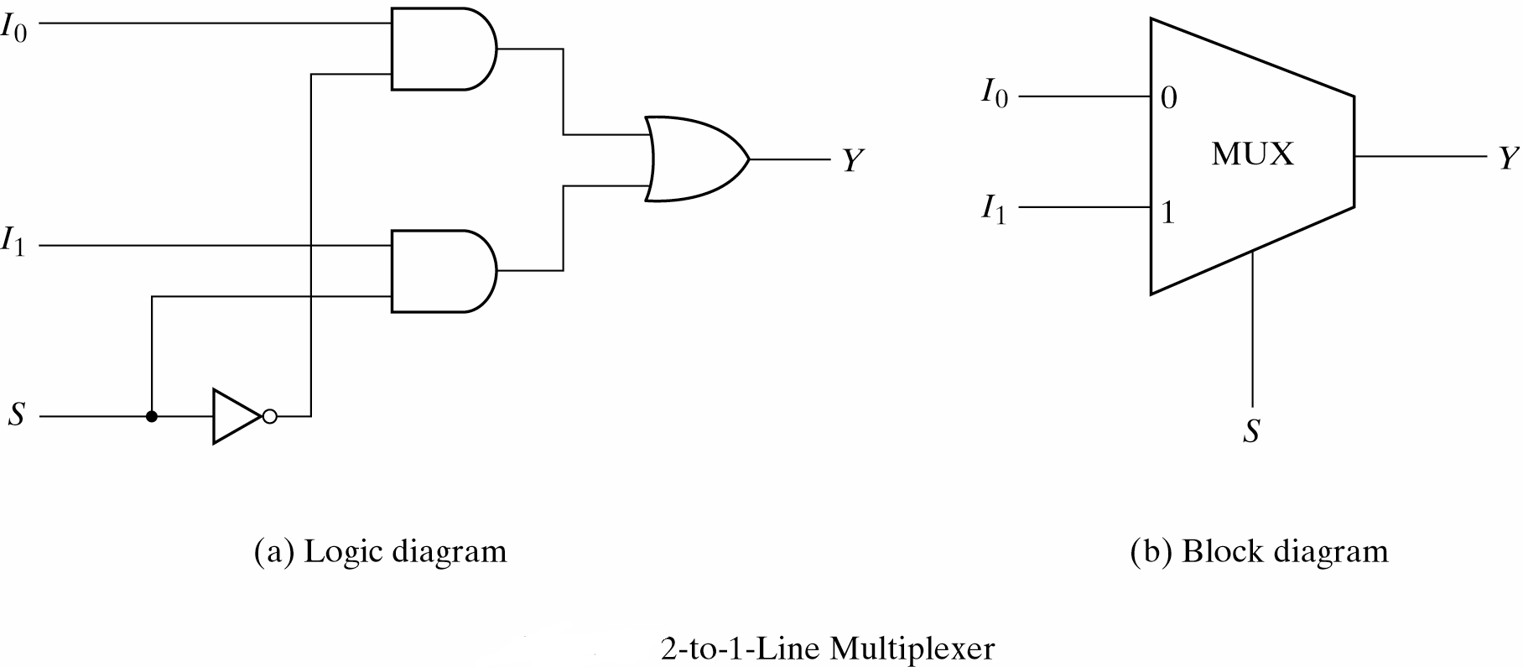
If S = 0, then S.I₁ = 0 and S .I₀ = I₀. Hence for S = 0 input I₀ is selected.
4-1 Multiplexer

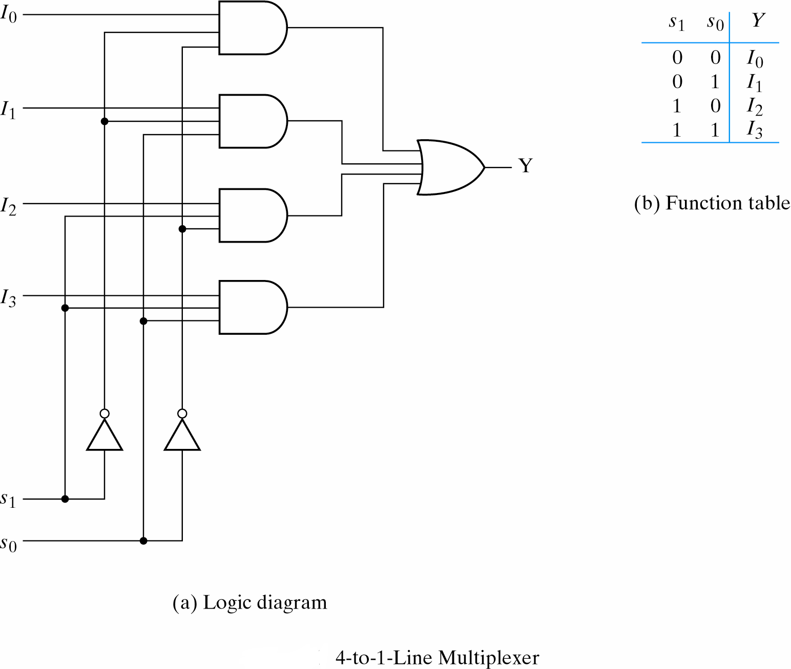

2.11 Boolean Function Implementation using Multiplexer

It is possible to implement Boolean functions using MUX. Any n-variable logic function can be implemented using a smaller 2(n-1)-to-1 multiplexer and a single inverter (e.g 4-to-1 mux to implement 3 variable functions) as follows.

Express function in canonical sum-of-minterms form. Choose n-1 variables as inputs to mux select lines. Construct the truth table for the function, but grouping inputs by selection line values (i.e select lines as most significant inputs). Determine multiplexer input line values by comparing the remaining input variable and the function F for the corresponding selection lines value.

Four possible MUX input line values:

Connect to 0 if the function is 0 for both values of remaining variable.

Connect to 1 if the function is 1 for both values of remaining variable.

Connect to remaining variable if function is equal to the remaining variable.

Connect to the inverted remaining variable if the function is equal to the remaining variable inverted.

Example- 3-variable Function Using 8-to-1 MUX.

Implement the function F(X,Y,Z) = Σ(1,3,5,6) using an 8-to-1 MUX Connect the input variables X, Y, Z to MUX select lines. MUX data input lines 1, 3, 5, 6 that correspond to function minterms are connected to 1. The remaining MUX data input lines 0, 2, 4, 7 are connected to 0.

1
0
1 MUX
2
3

4
5
6
7

Output F

X Y Z (Select lines)
The same function we can generate by using 4 to 1 MUX. From the given function we have to select two variables as the select lines and one as the input line.
The given function is F(X,Y,Z) = Σ(1,3,5,6) =X’Y’Z+X’YZ+XY’Z+XYZ’
= X’Y’(Z) +X’Y(Z)+XY’(Z)+XY(Z’)
Realization of the function using 4-to -1 Multiplexer is given below.
Z
4-to- 1 MUX

F
Z’

X Y (Select Lines)
This can easily implemented by using karnaugh map.
Example: Implement F A,B,C,D = ∑(1,3,4,11,12,13,14,15) using 8 to 1 MUX.
Solution: In this A,B,C are used as select inputs. The Map and circuit diagram is given below.
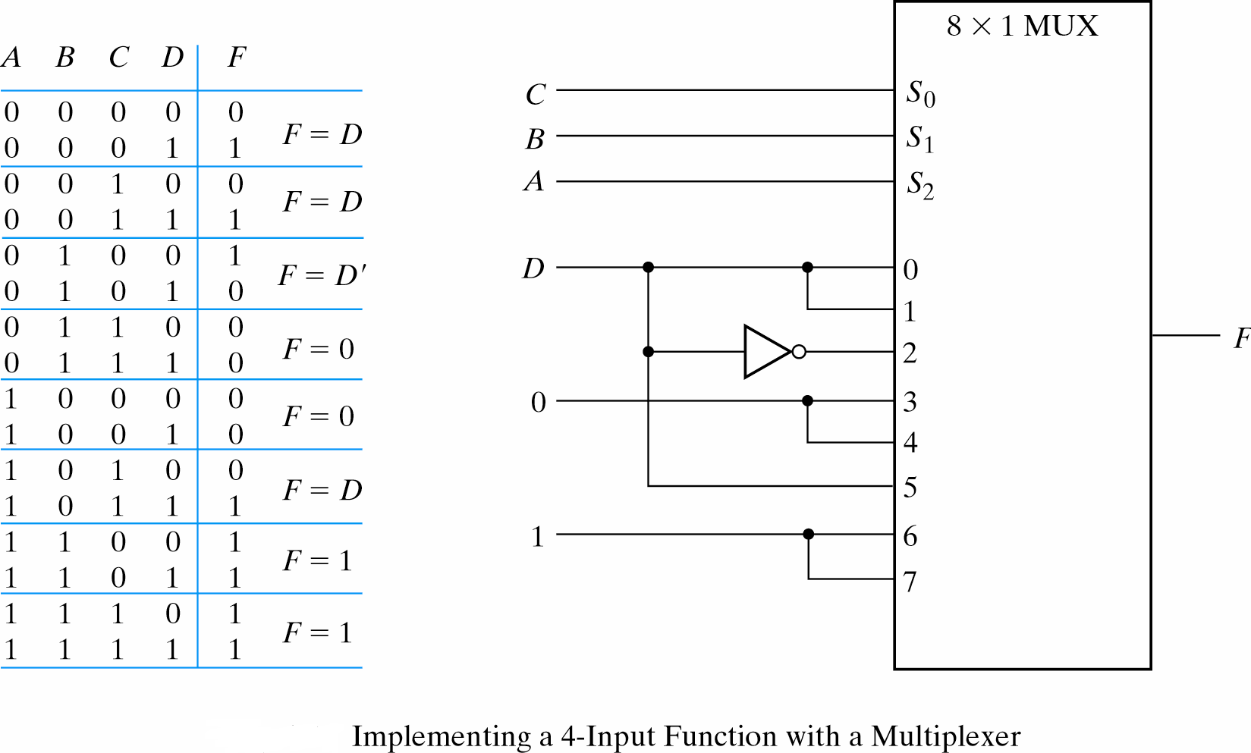
2.12 Demultiplexers
The opposite of the multiplexer circuit, is the demultiplexer. This circuit takes a single data input and one or more address inputs, and selects which of multiple outputs will receive the input signal. The same circuit can also be used as a decoder, by using the address inputs as a binary number and producing an output signal on the single output that matches the binary address input. In this application, the data input line functions as a circuit enabler — if the circuit is disabled, no output will show activity regardless of the binary input number.
With the help of the usual control signals, the i/p signal can be steered into one of the output lines.
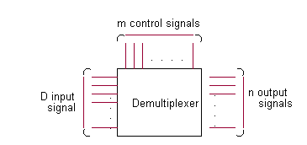
The input is marked D. The data bit is transmitted to the data bit y0, y1, .. yn if the output lines. A particular line to choose will depend upon the value of control lines.
1 to 4 line Demultiplexer
1-to-4 y0
DMUX y1
y2
y3
E

C0 C1
The complete logic circuit of 1- to 4- line Demultiplexer is given below.
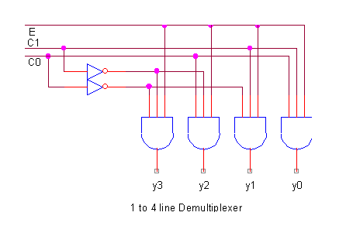
It accepts two control signals C0, C1, and gives four mutually exclusive active high outputs y0, y1, y2, y3. The line E acts as enable or Strobe. When E is high the data can be transmitted. E can be used as the data input when the device is used as 4 output multiplexer.
Consider a 1-to-8 line DMUX. a2 a1 a0 are the select inputs and d is the data input. Output line are x1,x2,x3,x4,x5,x6,x7. The complete truth table is given below.
a2 a1 a0 d | x7 x6 x5 x4 x3 x2 x1 x0
-------------------------------------
0 0 0 c | 0 0 0 0 0 0 0 c
0 0 1 c | 0 0 0 0 0 0 c 0
0 1 0 c | 0 0 0 0 0 c 0 0
0 1 1 c | 0 0 0 0 c 0 0 0
1 0 0 c | 0 0 0 c 0 0 0 0
1 0 1 c | 0 0 c 0 0 0 0 0
1 1 0 c | 0 c 0 0 0 0 0 0
1 1 1 c | c 0 0 0 0 0 0 0

Logic circuit is given below.
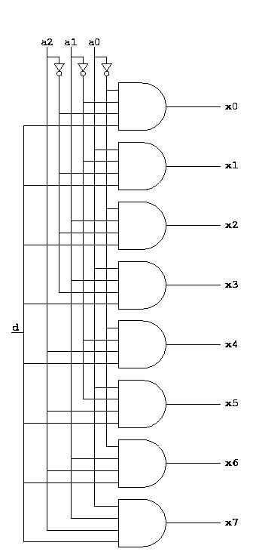

2.13 Decoder

A decoder has N inputs and 2N output lines; each of the 2N possible patterns of bits on the inputs corresponds to one of the output lines, and when that input pattern appears, the corresponding output line is set high (given the value 1).
And AND gate can be used as the basic decoding element. Because its output is HIGH only when all its inputs are HIGH. A binary decoder has n inputs and 2^{n} outputs. Only the one output is active at any point of time, corresponding to the input value. Figure below shows a representation of Binary n-to-2^{n} decoder. Decoder is also called minterm generator.

N to 2^{n} Decoder
N Inputs .. . 2^{n} output
. .
. .

Example - 2-to-4 Binary Decoder A 2 to 4 decoder consists of two inputs and four outputs, Truth table and symbols of which is shown below.
X | Y | F0 | F1 | F2 | F3
0 | 0 | 1 | 0 | 0 | 0
0 | 1 | 0 | 1 | 0 | 0
1 | 0 | 0 | 0 | 1 | 0
1 | 1 | 0 | 0 | 0 | 1
x F0
2 to 4 Decoder
.. F1
y F2
F3

3 to 8 decoder circuit is given below.
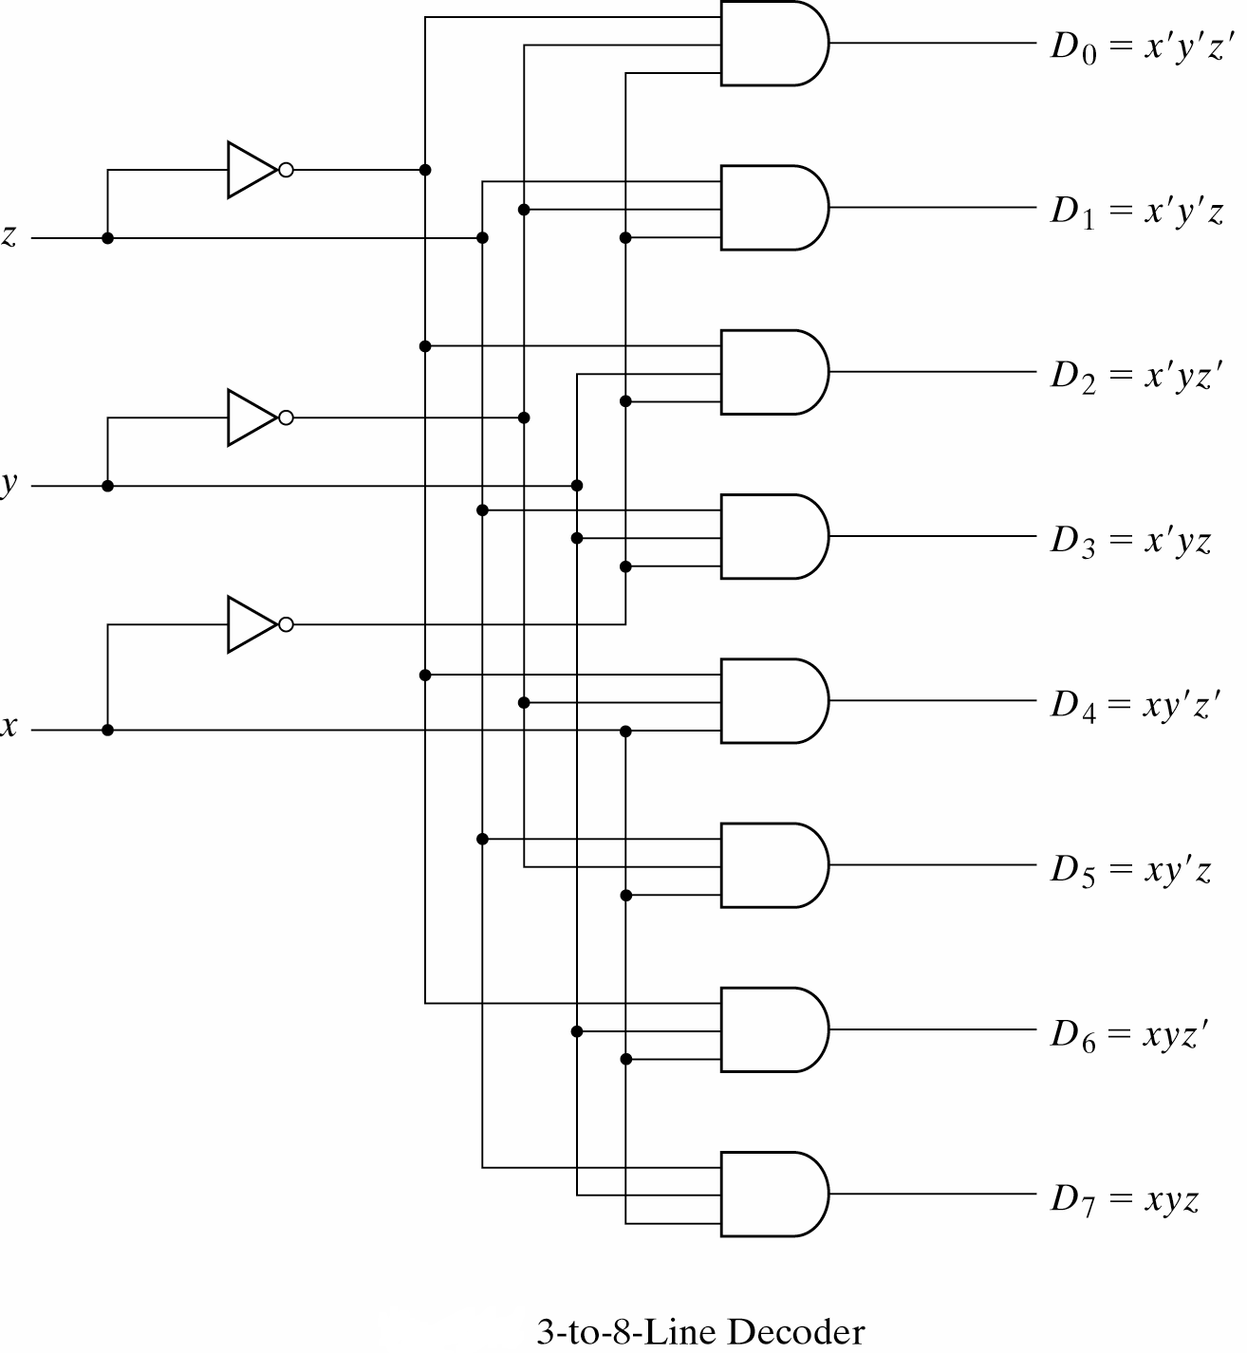

Decoders usually have an enable line, If enable=0 , decoder is off. It means all output lines are zero If enable=1, decoder is on and depending on input, the corresponding output line is 1, all other lines are 0. Truth table for the 2 to 4 line decoder with enable input is given below.

E a2 a1 a0 D7 D6 D5 D4 D3 D2 D1 D0
-----------------------------------------------------------
0 x x x 0 0 0 0 0 0 0 0
1 0 0 0 0 0 0 0 0 0 0 1
1 0 0 1 0 0 0 0 0 0 1 0
1
1 ……………………………………….
1 ……………………………………..
1
1
1 1 1 1 1 0 0 0 0 0 0 0

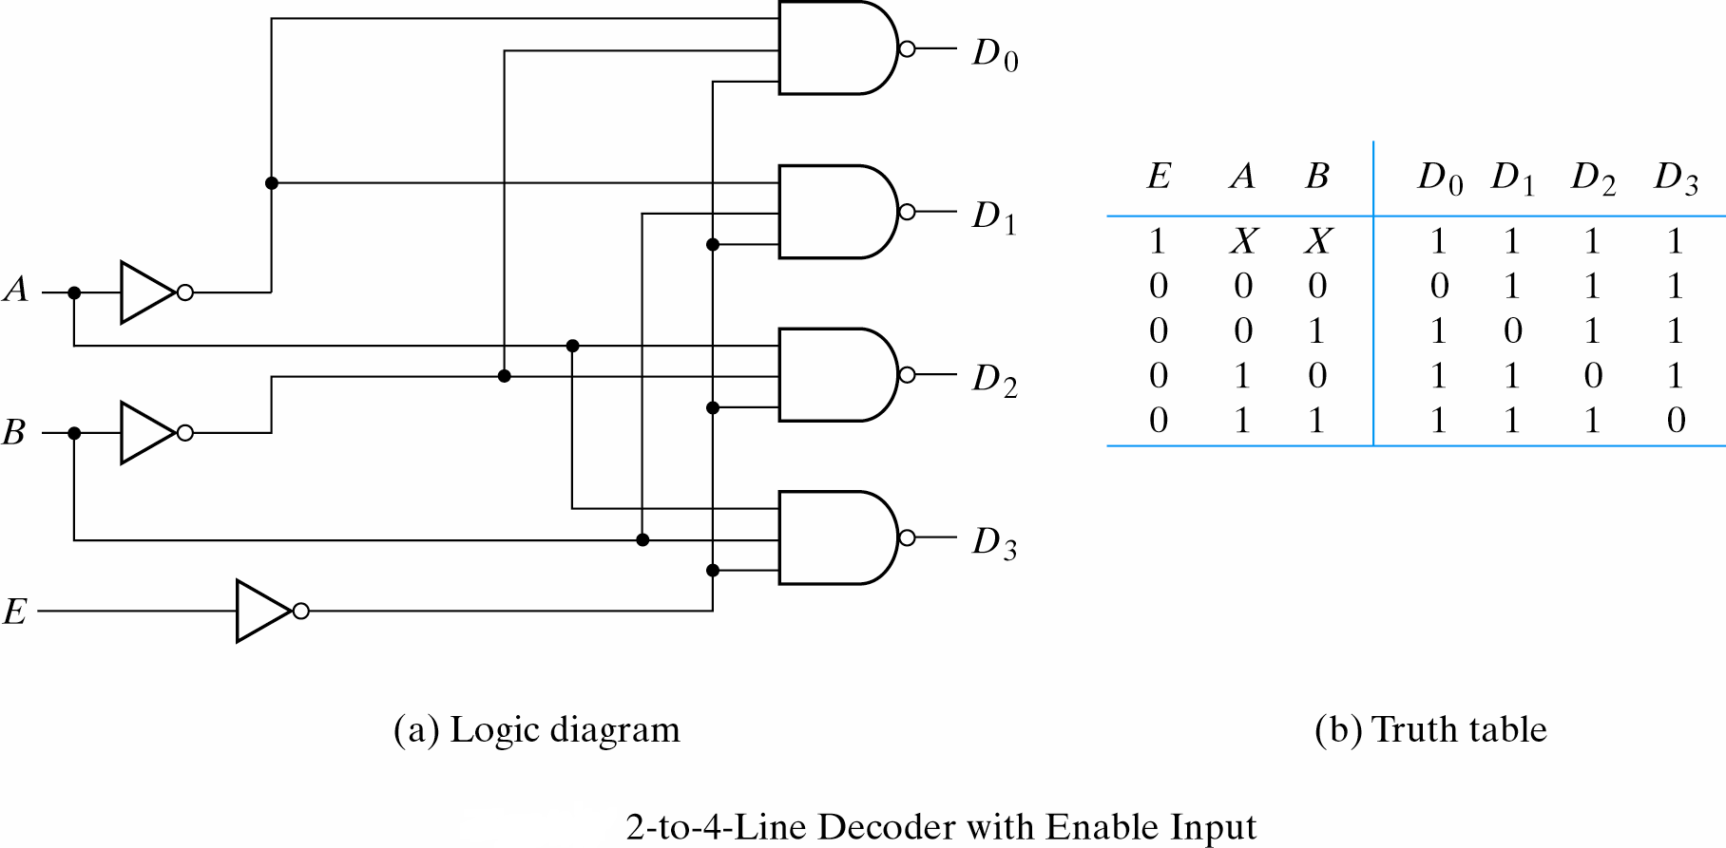

2. 14 Implementing Logic Functions Using Decoders
Any n-variable logic function, in canonical sum-of-minterms form can be implemented using a single n-to-2^{n} decoder to generate the minterms, and an OR gate to form the sum. The output lines of the decoder corresponding to the minterms of the function are used as inputs to the OR gate.
For example the truth table for full adder is s (x,y,z) = ∑ ( 1,2,4,7) and C(x,y,z)= ∑ (3,5,6,7).
The implementation of full adder with decoder is:
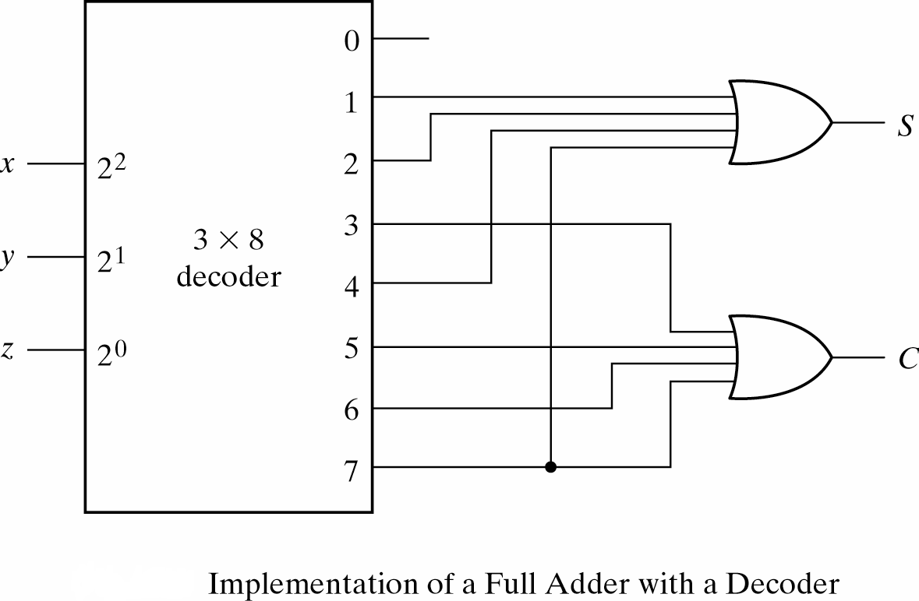

2.15 Encoder

Encoder is a digital circuit that performs the inverse operation of a decoder. This Generates a unique binary code from several input lines. Generally encoder produce2-bit, 3-bit or
4-bit code. n bit encoder has 2^{n} input lines.

Binary Encoder
2^{n} inputs n Ouput lines

2-bit Encoder
If one of the four input lines is active encoder produces the binary code corresponding to that line
2 bit Binary Encoder

If more than one of the input lines will be activated or all the output is undefined. We can consider don’t care for these situations but in general we can solve this problem by using priority encoder.
A priority encoder is an encoder circuit that includes priority function. It means if two or more inputs are equal to 1 at the same time, the input having higher subscript number, considered as a higher priority. For example if D3 is 1 regardless of the value of the other input lines the result of output is 3 which is 11. If all inputs are 0, there is no valid input. For detecting this situation we considered a third output named V. V is equal to 0 when all input are 0 and is one for rest of the situations of TT.

Consider a 2 bit (4 input) priority encoder. By using TT and K-map we get following Boolean functions for 4-input (or 2-bit) priority encoder:
- X = D2 + D3
- Y = D3 + D1D’2
- V= D0 + D1 + D2 + D3

